**Nama : Allan Wydianto**

**Kelas : FWD Batch 4**

**Github : https//github.com/w1shm3luck/mini-project**

Menyelesaikan beberapa soal menggunakan dummy data

1. Create Query to find listof movie that released in 2021

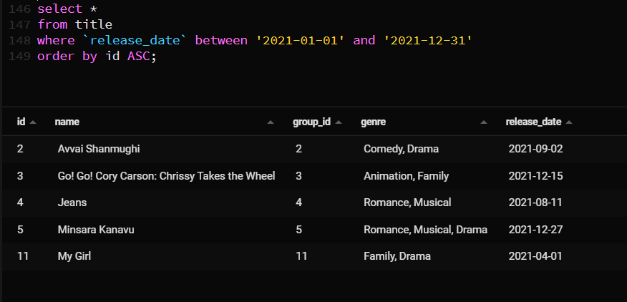

1. 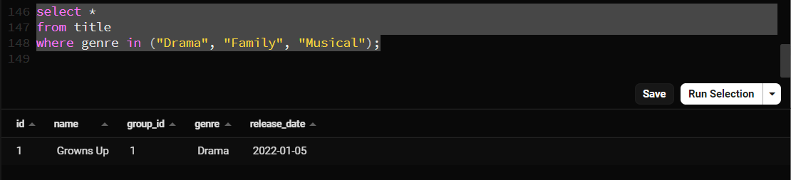Create query to find a list movie with genres drama, family, or musical
2. 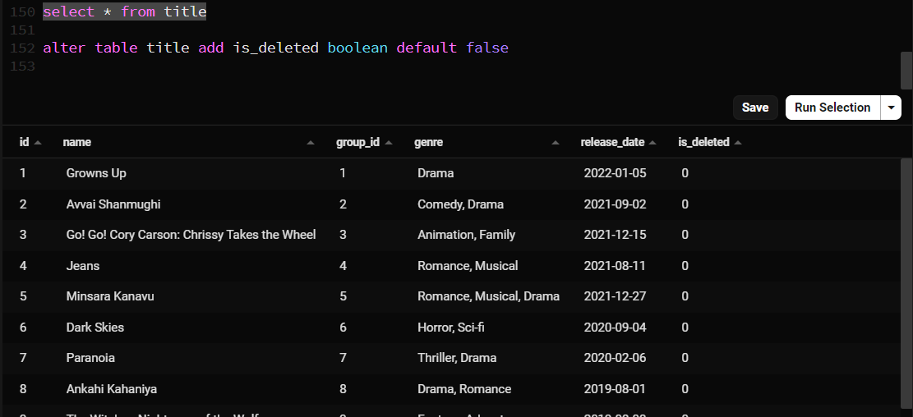Alter Movie Table
3. 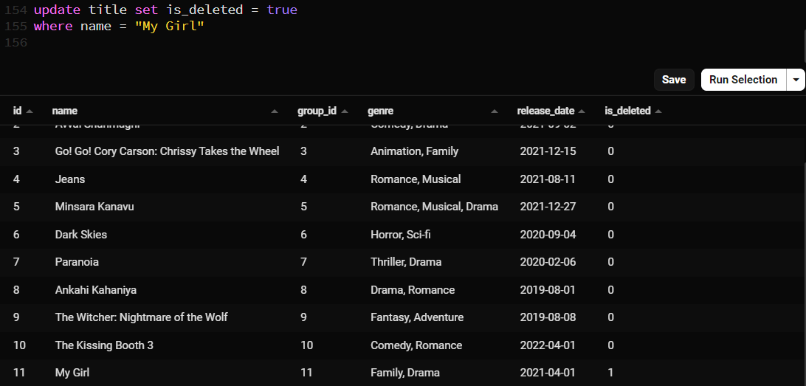Create Query Soft delete
4. 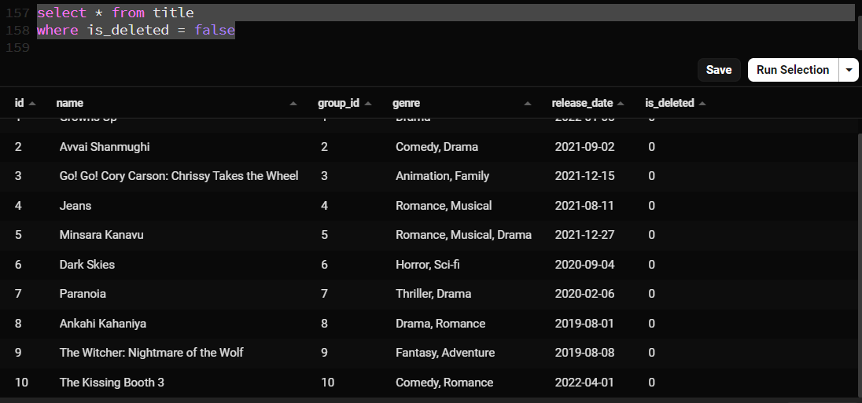Select All movie excluded soft deleted